**New Partner Setup**

# **API Gateway Configuration:**

**Step1**: Generate API Key for new Partner.**@TODO@**

**Step2**: Login to ConfigUI

http://<host>:<port>/ConfigUI/

**Step3**: Click on the existing project where you need to add new Partner

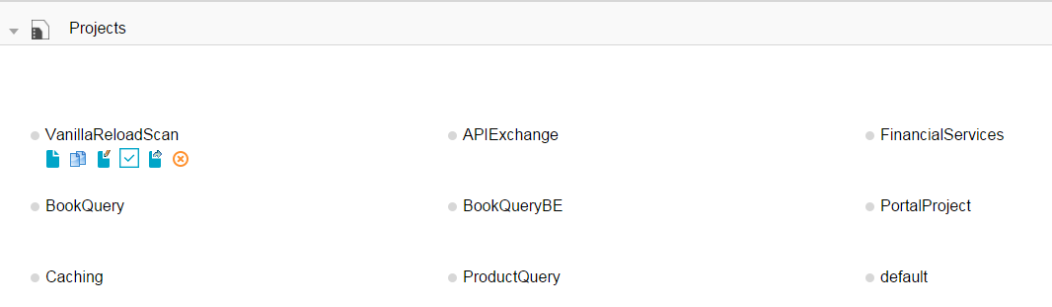

**Step4**: Click on the PARTNER tab 🡪In Partners section 🡪 Create new partner by clicking on **+** icon (add property) and save it.

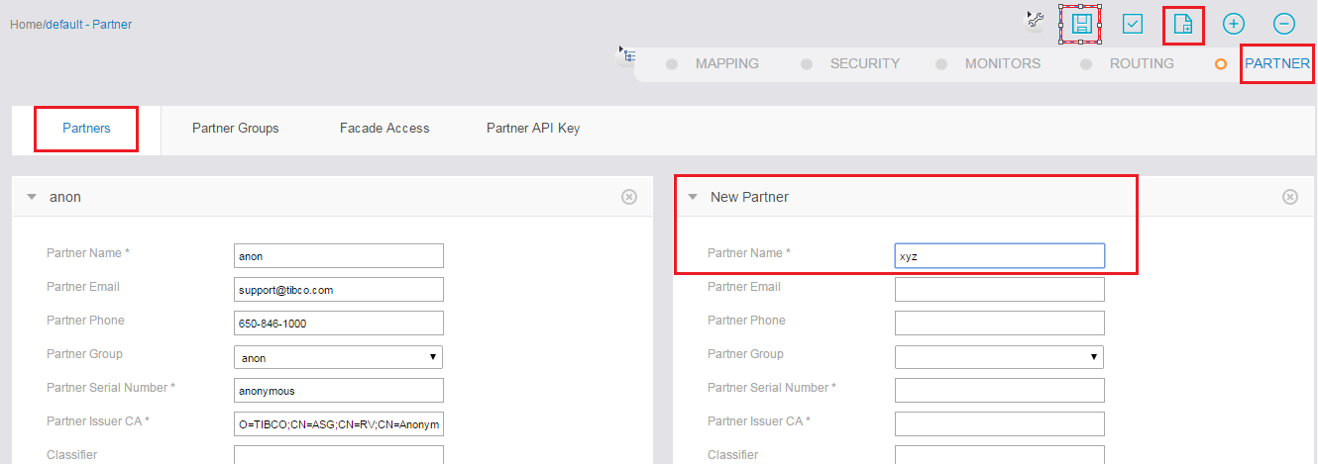

**Step5**: Now navigate to PARTNER tab 🡪 In Partner API Key section 🡪 Configure API Key for new Partner by clicking on **+** icon (add property) and save it.

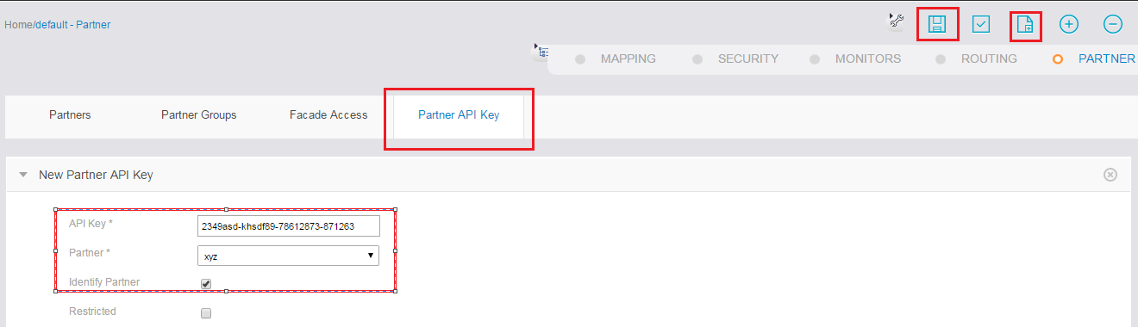

**Step6**: Provide access to appropriate APIs for the new Partner as shown below.

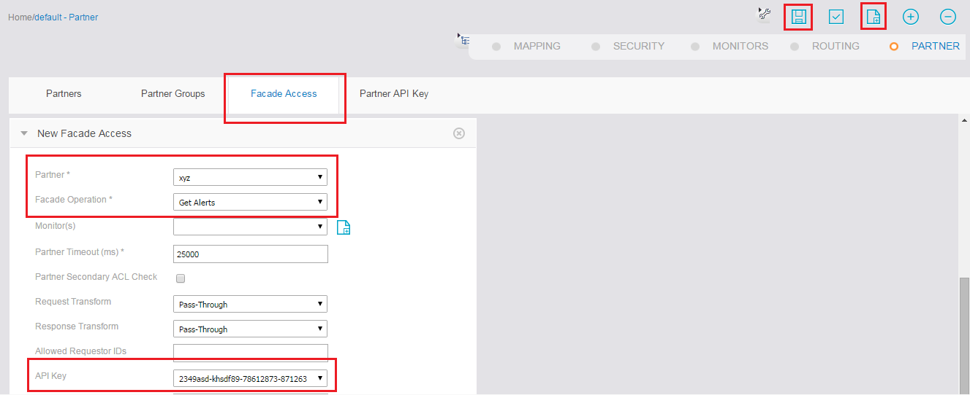

**Step7**: Save the project & restart asg-engine.

Add new Partner details in APIX DB tables using below insert commands.

# **Database Configuration:**

***APIX 🡪 PARTNERS***

e.g.:

Insert into APIX.PARTNERS (PARTNER_ID,PARTNER_NAME,DESCRIPTION,PARTNER_URI,CREATED_BY,CREATED_DATE,UPDATED_BY,UPDATED_DATE,VALIDATNG_SYSTEM,PARTNER_CLASS,APIKEY,AGGREGATOR_ID,APPLICATION_NAME) values ('10','xyz','xyz descr','/xyz/','apix',to_date('25-FEB-16','DD-MON-RR'),null,null,'VMS','GPR','2349asd-khsdf89-78612873-871263',null,'FSAPI');

***APIX 🡪 KEYMANAGEMENT***

e.g.:

Insert into APIX.KEYMANAGEMENT (PARTNER_ID,KEY_EXPIRY_IN_DAYS,CURRENT_KEY,CURRENT_KEY_CREATION_DATE,PREVIOUS_KEY,PREVIOUS_KEY_CREATION_DATE,AGGREGATOR_ID) values ('10',30,'097F6A432DBCAE9BA7AC523A62F1D416B05A49214FD2C51BEAAF1CA0739F517F',to_date('24-MAR-16','DD-MON-RR'),'4A47FB4152F0CA7B32EE8CA2DCF09055B7903887DFBD420B1BB6484E30DC698C',to_date('24-FEB-16','DD-MON-RR'),'0');